

**WORKSHEET No: 1**

**Subject: Mathematics**

|  |  |
| --- | --- |
| **Name:** | **Class: 3** |
| **Name of the Teacher:** | **Date:** |
| **Topic: Large Numbers** | |

**I. Fill in the blanks:**

1. 1 Ten = ___________ ones.
2. 1 Hundred = ___________ Tens.
3. 10 Hundred = ___________ Thousand
4. The predecessor of a number is ___________ less than the number.
5. The successor of 999 is ___________.
6. The predecessor of 7390 is ___________.
7. The place value of 5 in 6538 is ___________.
8. The face value of 7 in 6378 is ___________.
9. The predecessor of 2000 is ___________.
10. A number that comes just after a given number is called its ______________.
11. The successor of a number is ___________ more than the number.
12. The place value and face value of ____________is always zero.
13. A number that comes just before a given number is called its ______________.
14. The successor of 5999 is ___________.
15. 9435 = 9000 + ____________ + ___________ + ____________.
16. If you add one to an odd number it will become a _____________ number

**II. Write the five consecutive numerals:**

1. 5098 _________, _________, _________, ________, ________.
2. 9900 _________, _________, _________, _________, ________.
3. 7999 _________, _________, _________, _________, ________.
4. 4079 _________, _________, _________, ________, _________.
5. 5899 _________, _________, ________, ________, _________ .

**III. Write the five preceding numerals:**

1. _________, _________, _________, _________ , _________,6892 .
2. _________ , _________ , _________ , _________ , _________,7520 .
3. _________ , _________ , _________ , _________ , _________ , 6700.
4. _________ , _________ , _________ , _________ , _________ , 9670.
5. _________ , _________ , _________ , _________ , _________ , 8000.

**IV. Use the numbers in the box to form other numbers:**

1, 7, 8, 3

9, 1, 5, 2

1. Smallest 4-digit number: _____________________.
2. Largest 3-digit number _____________________.
3. Smallest 2-digit number _____________________.
4. Largest 4-digit number ______________________.
5. Largest 2-digit number ____________________
6. Smallest three-digit number _________________
7. Largest four-digit number ________________.
8. Smallest four-digit number _________________.
9. **Circle the odd numbers:**
10. 2345, 8767, 2098,3482, 1011,2346.
11. 8643, 3890,1298, 3423, 7820,2180.
12. **Circle the even numbers:**
13. 3444, 8904,3477,8117,3219,7382.
14. 2901,6723,7896,5329,2390,2179.
15. **Round off to the nearest 10’s:**
16. 23 -_____________.
17. 368 -_____________.
18. 771 -_____________.
19. 2568-_____________.
20. 1099-_____________.

**VIII. Round off to the nearest 100’s:**

1. 345-_____________.
2. 6753-_____________.
3. 8789-_____________.
4. 5097-_____________.
5. 6987-_____________.

**VIII. Arrange in ascending order:**

1. 2345, 2435, 2534, 2453. ____________________________________________________________.
2. 7648, 3892,6710, 4789. ____________________________________________________________.

**IX. Arrange in descending order:**

1. 7510,7150,7501,7105. ____________________________________________________________.
2. 9810,4567,7829,2391. ____________________________________________________________.

**X. For the given numbers, add the missing beads in the abacus:**

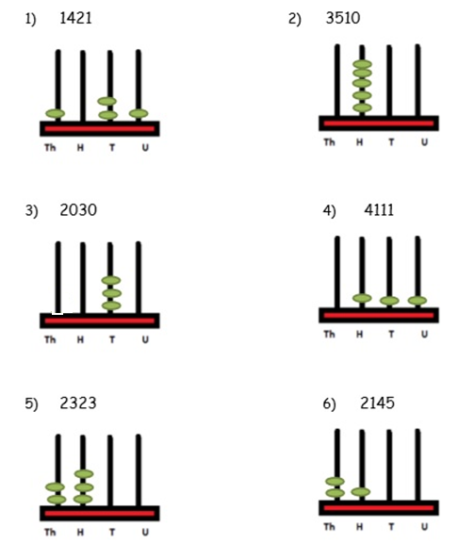

**XI. Compare the numbers (>, < or =)**

|  |  |  |
| --- | --- | --- |
| **2178** |  | **2718** |
| **2109** |  | **1290** |
| **9837** |  | **9873** |
| **6549** |  | **6546** |

**HOTS: Who am I?**

1. I am the predecessor of the smallest 5-digit number. _______________.
2. If I am added or subtracted from a number, the answer is the number itself. _________.
3. I am a number with the digits ‘3’, ‘4’, ‘5’ and ‘2’. I am the greatest possible number between 5000 and 5500. I have no repeated digits. What number am I? _________________.
4. If 1000 is subtracted from me, I become 3333. ­­­­­­­­­­­­­­____________________.
5. Express the number 1302 in two different forms:
6. Number Name-________________________________________________________________________________
7. Expanded form-_______________________________________________________________________________

**VBQ:** Diya donates money to the needy. Till now she has donated equivalent to the largest number that could be formed using the digits 5, 2, 8 and 3. Can you find the total amount she has donated until now? __________________________.

Why should we help the needy people?

___________________________________________________________________________________________________________________________________________________________________________________________________________________________________________________________________________________________________________________________________________________________________________________________________________________­­­­­­­­­­­­­­­­­­­________________________.